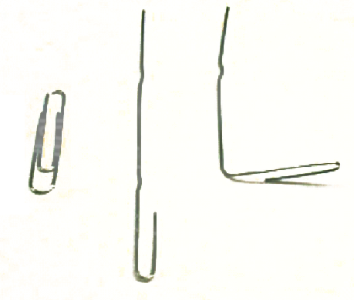
The Sound Box:

  - Unfold halfway one of the large paper clips and then bend it as seen in the picture.

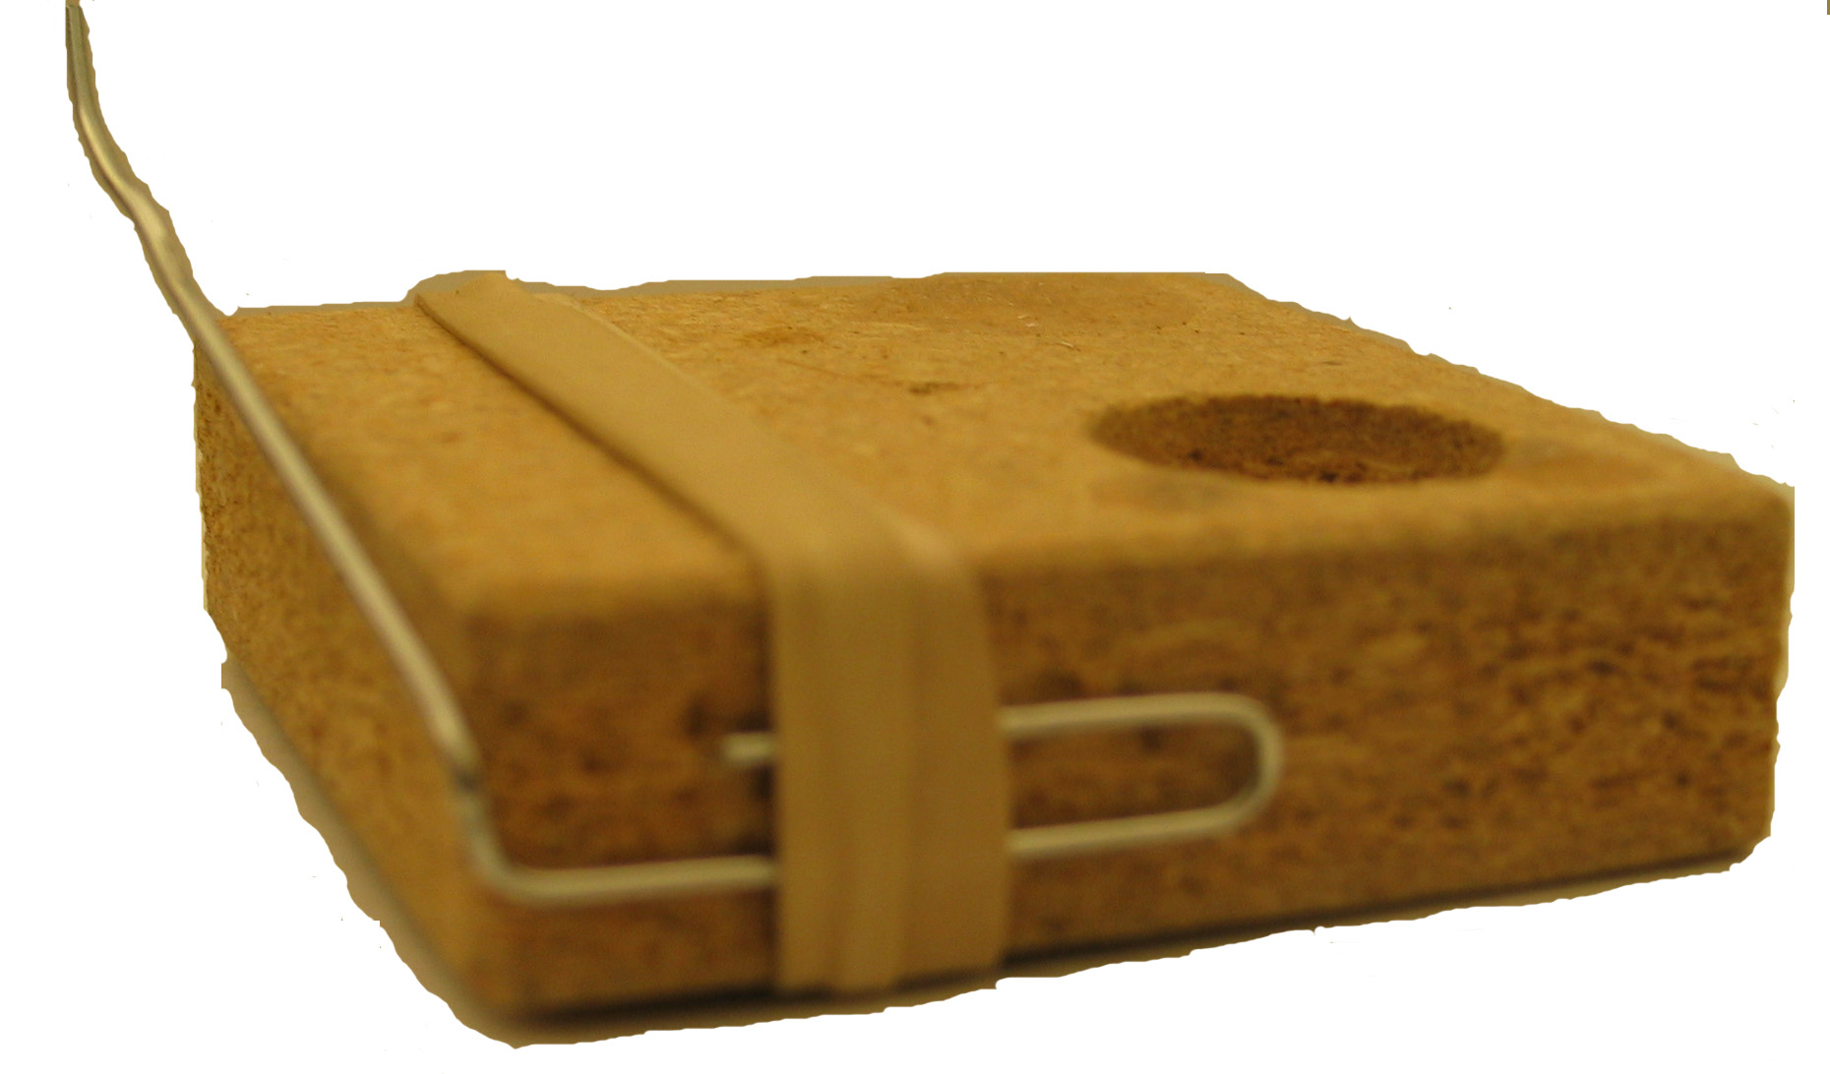
  - Rubber band the folded part of paper clip onto the edge of a piece of wood.

  - 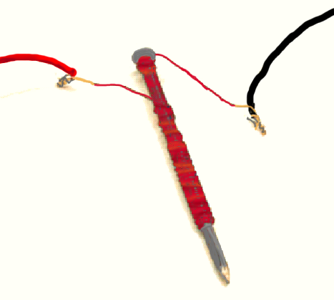Test your electromagnet by touching the wires to the terminals of a battery and try to pick up some paper clips. If it doesn’t, sand more of the paint off the ends of your magnet wire then test it again.

  - Strip the ends of your red and black wires.

  - Twist together one end of your red wire and one end of the magnet wire. Do the same with the long black wire and the other end of magnet wire.

  - Use a rubberband to hold the nail and the bent paperclip in place.

  - Adjust the bend of your paper clip so that it hangs just above the head of the nail.
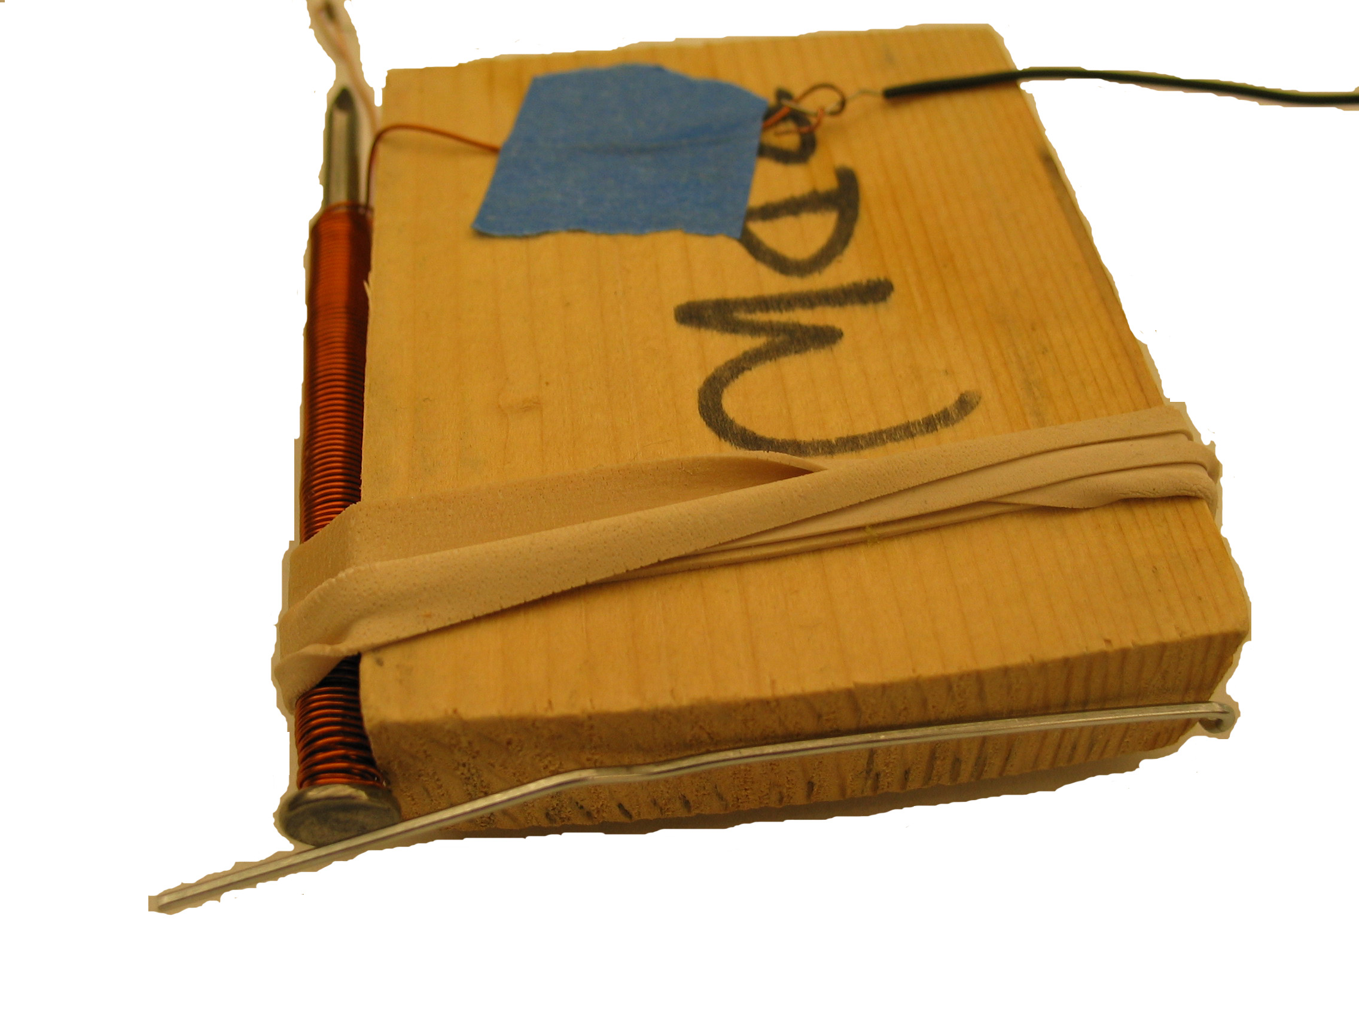

  - Twist together the free end of your red wire and the red wire of your battery pack.

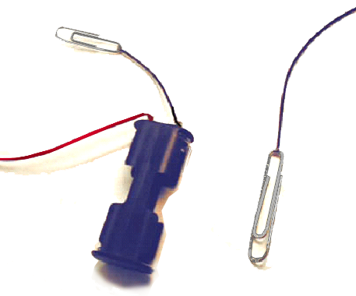
The Control

- Twist the free end of your long black wire around your second large paper clip.

- Twist one end of your short black wire around the small paper clip, and the other end together with the black wire of your battery pack.

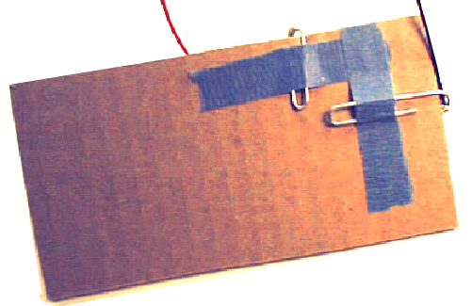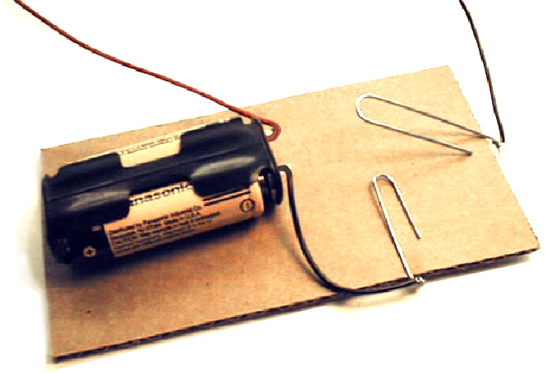

3. Tape your paper clips onto a piece of cardboard, so the small loop of both paperclips is on the bottom of the cardboard. Make sure they don’t touch.

- On the other side of your cardboard, bend up the big paper clip, so it hangs above the small paper clip.

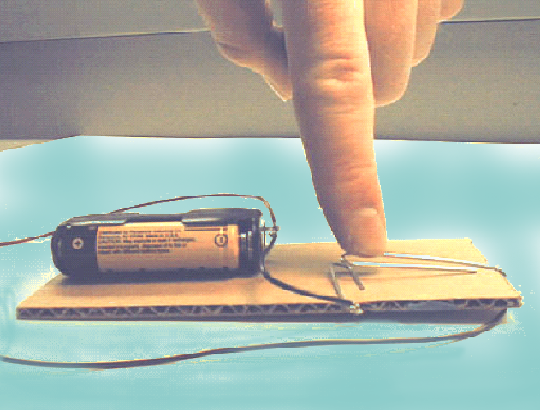How to Use Your Telegraph:
Put the batteries into your battery pack. Press the big paper clip down until it touches the small paper clip. When they touch you complete a circuit sending electricity to your electromagnet, attracting the paperclip above it, making a ‘click’. If your telegraph doesn’t work try adjusting your paper clip so it hangs closer to the nail.

